Experiment 3 – DSP Lab

Mohadeseh Azari, 810196404

- Part One
Question 1:
Find the function of this echo system.
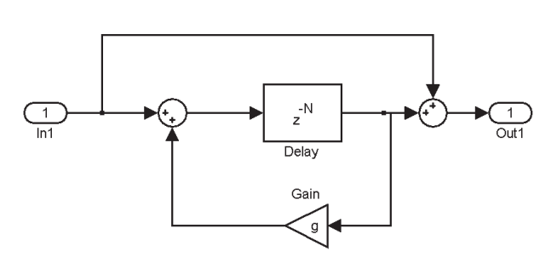

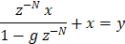
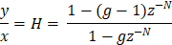

The maximum number of g is 1, g < 2. Because for being stable it must contain the z=1 circle

For the echo part the original voice and the echo voice are provided in the folder as well.

- Part 2
Question 1:

